**Quiz # 1: Student ID: ________________ Date: 22/06/2019**

**___________________________________________________________________**

**Knight** is the piece name used in Chess Game, The possible moves are shown in Figure 3 and you have observed the moment of knight is in “L” shape everywhere.

Consider the problem of moving a knight on a 3x4 board, with start and goal states labeled as S and G in figure on LEFT SIDE. The letter in each node is its name and the subscript digit is the heuristic value. All transitions have cost 1.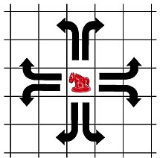

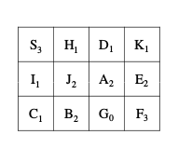

1. Write Successor Function (aka Expand Function) for above problem. Your algorithm should take state as input and return all possible next states (successor states). Mention which data structure and how you will store state of mentioned problem.